Bidding Tip Sheet

This document provides suppliers with detailed instructions on what to do after receiving an email notification of a sourcing event.

- Once the sourcing event is created you will receive an email notification. Look for the email in your registered email address mailbox.
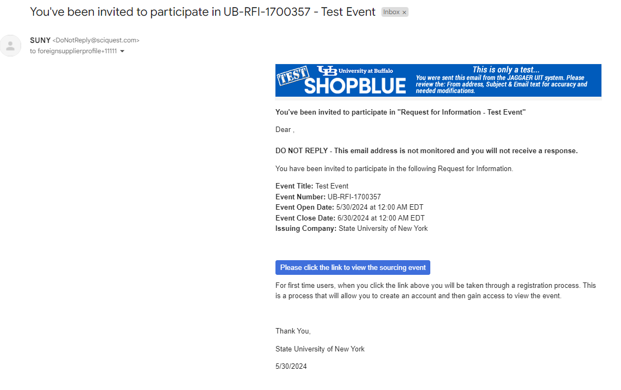

- Click the below link to view the Sourcing Event.
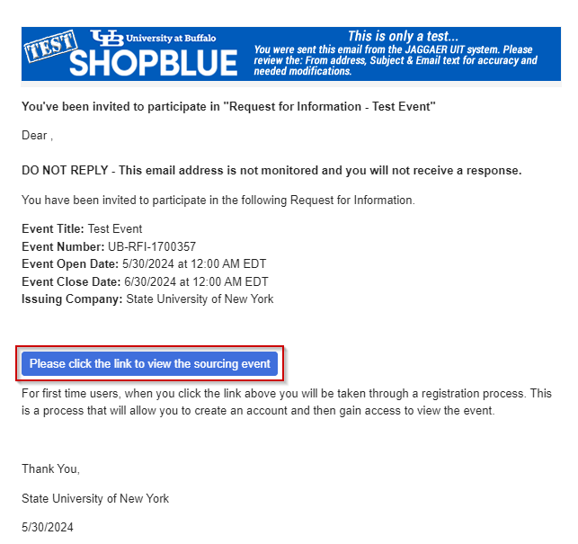

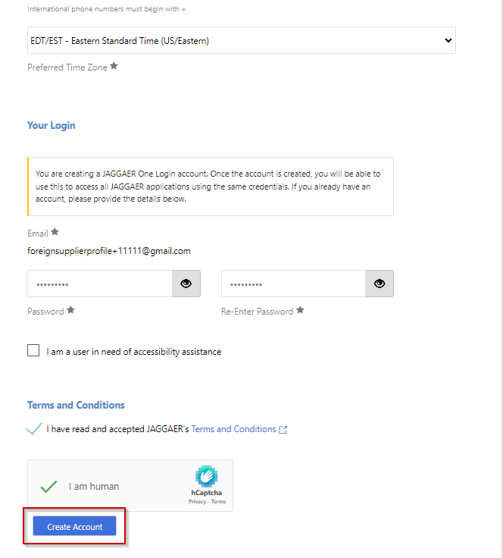
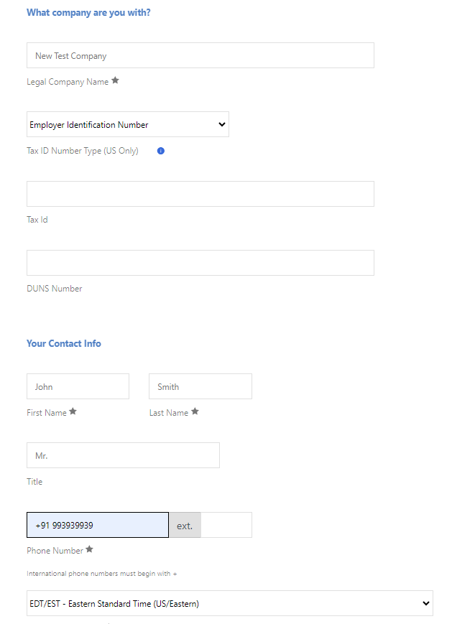
- Fill all required company details. Enter the Password and Click Create Account.

- Once the account has been created, you will receive an email for next steps.
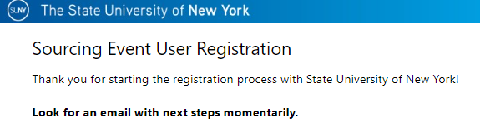

- Look for the email to continue with Sourcing Event Supplier Registration. Click Complete Registration Now.
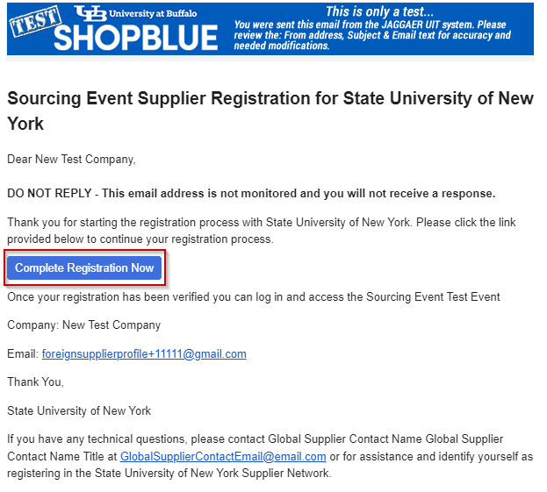

- Login page will appear, confirm your email address, and click Next.
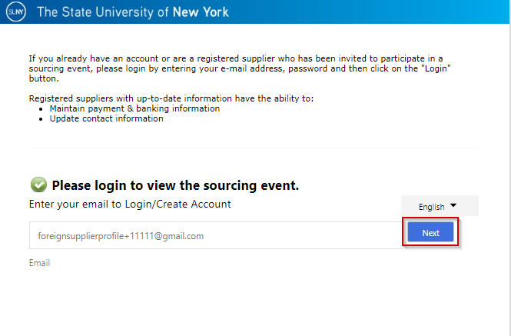

- Enter the password you have created and click Login.
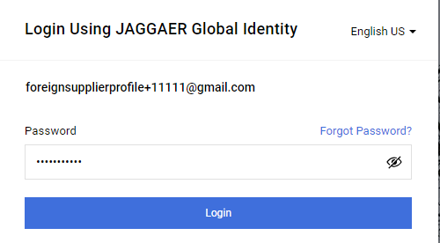

- Enter One Time Code and Click Submit.
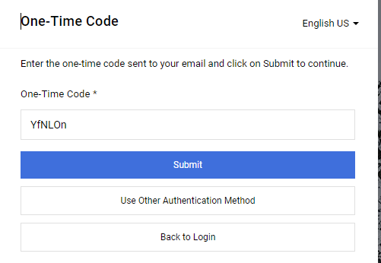

- Once you are logged-in, the sourcing event you are invited to will appear on the home page. Click View Event to view the Event.
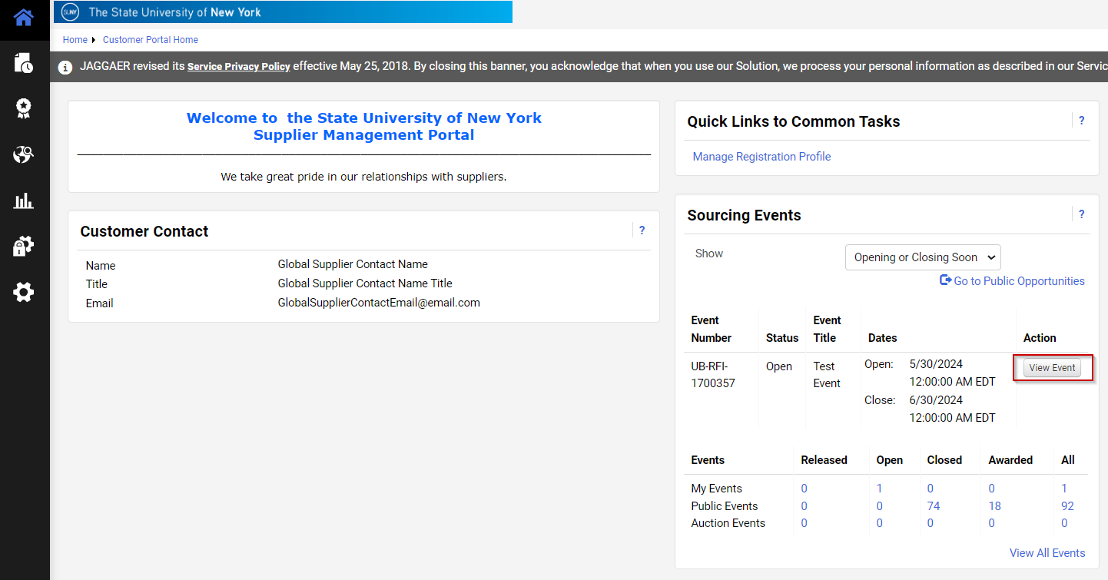

- On the Event Page Scroll down to view the Description Page.
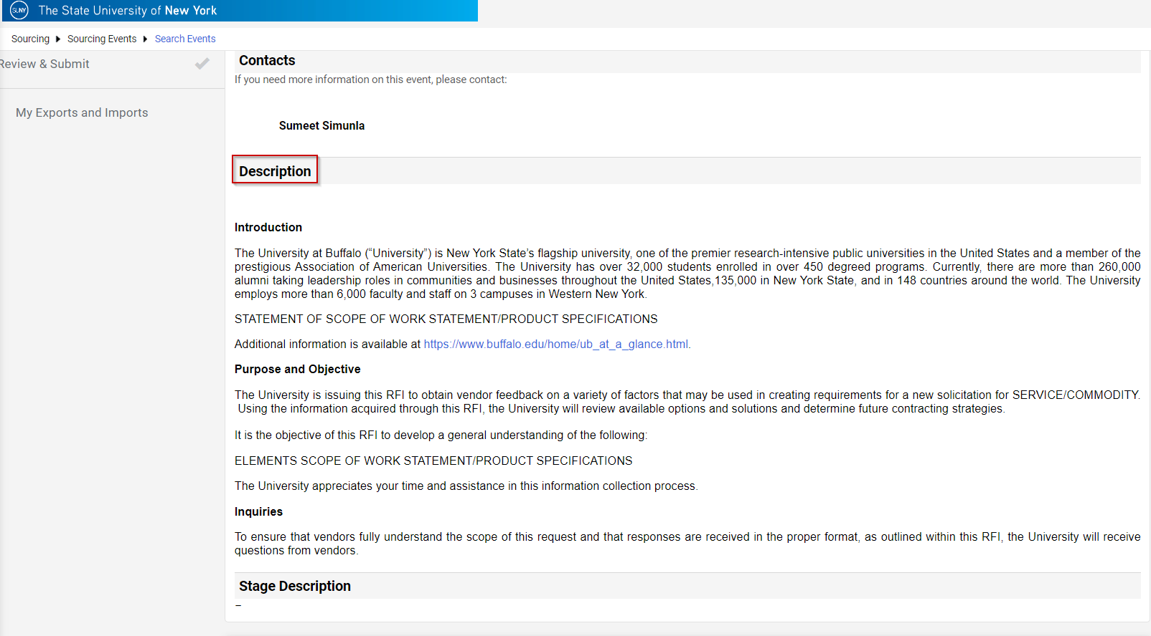

- After checking the Description, Click Proceed to Prerequisites.
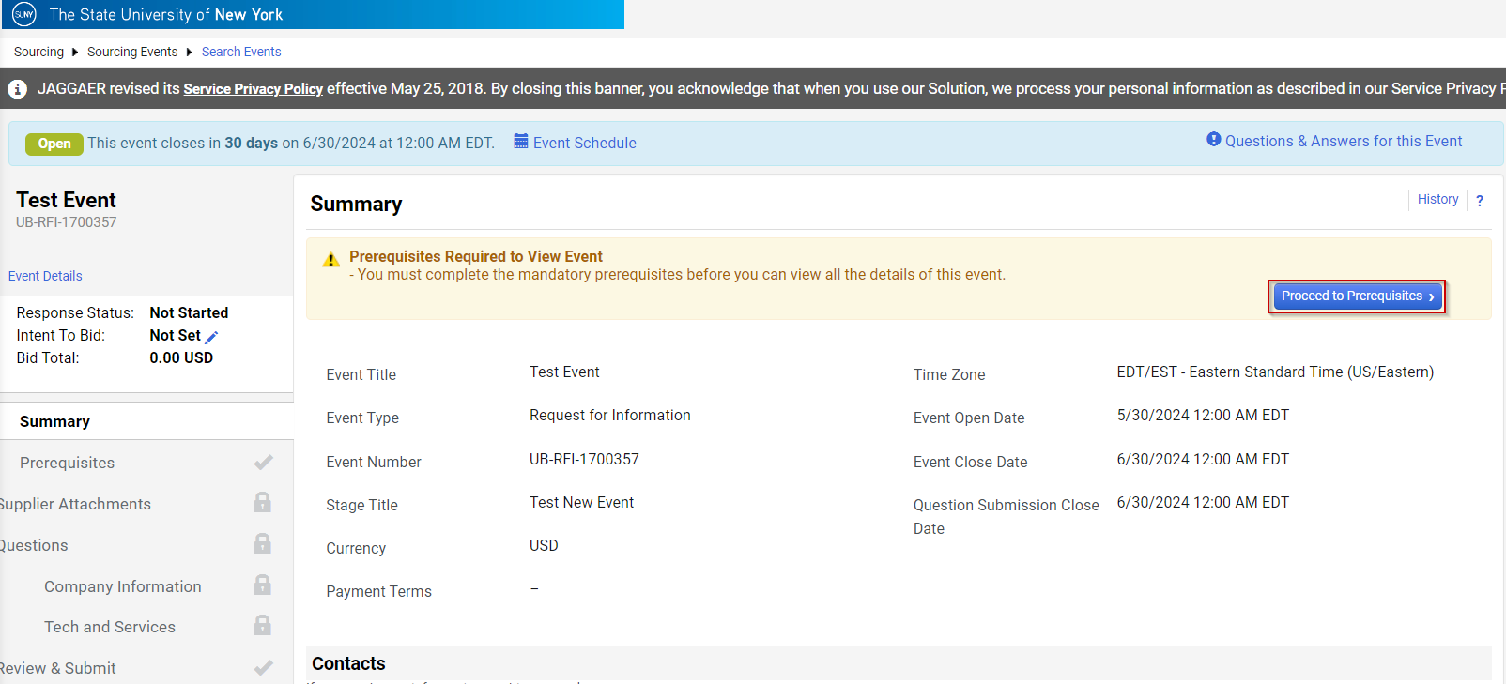

- Download to view Terms and Conditions, check the radio button for agree terms and conditions and click Save Progress.
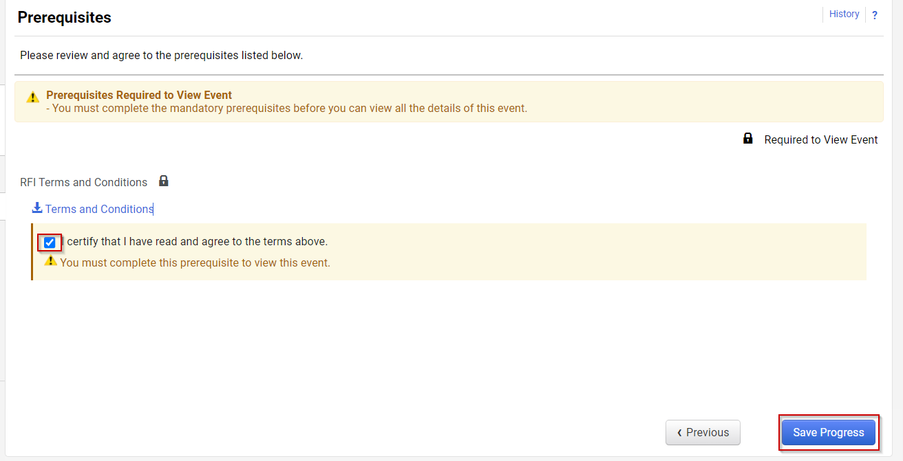

- Click Yes, I intend to bid.
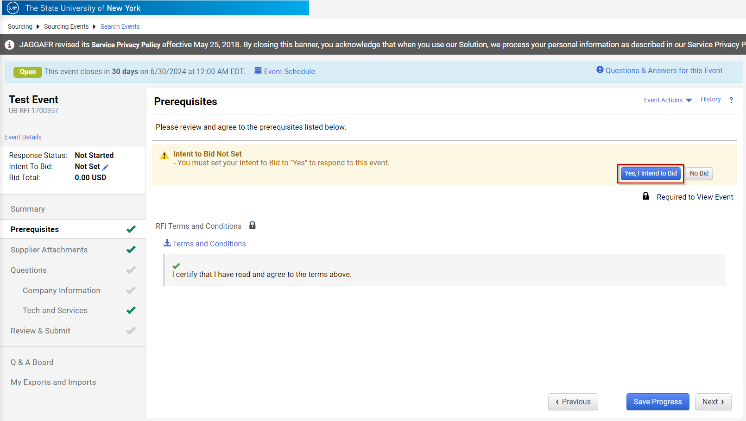

- Click Next.
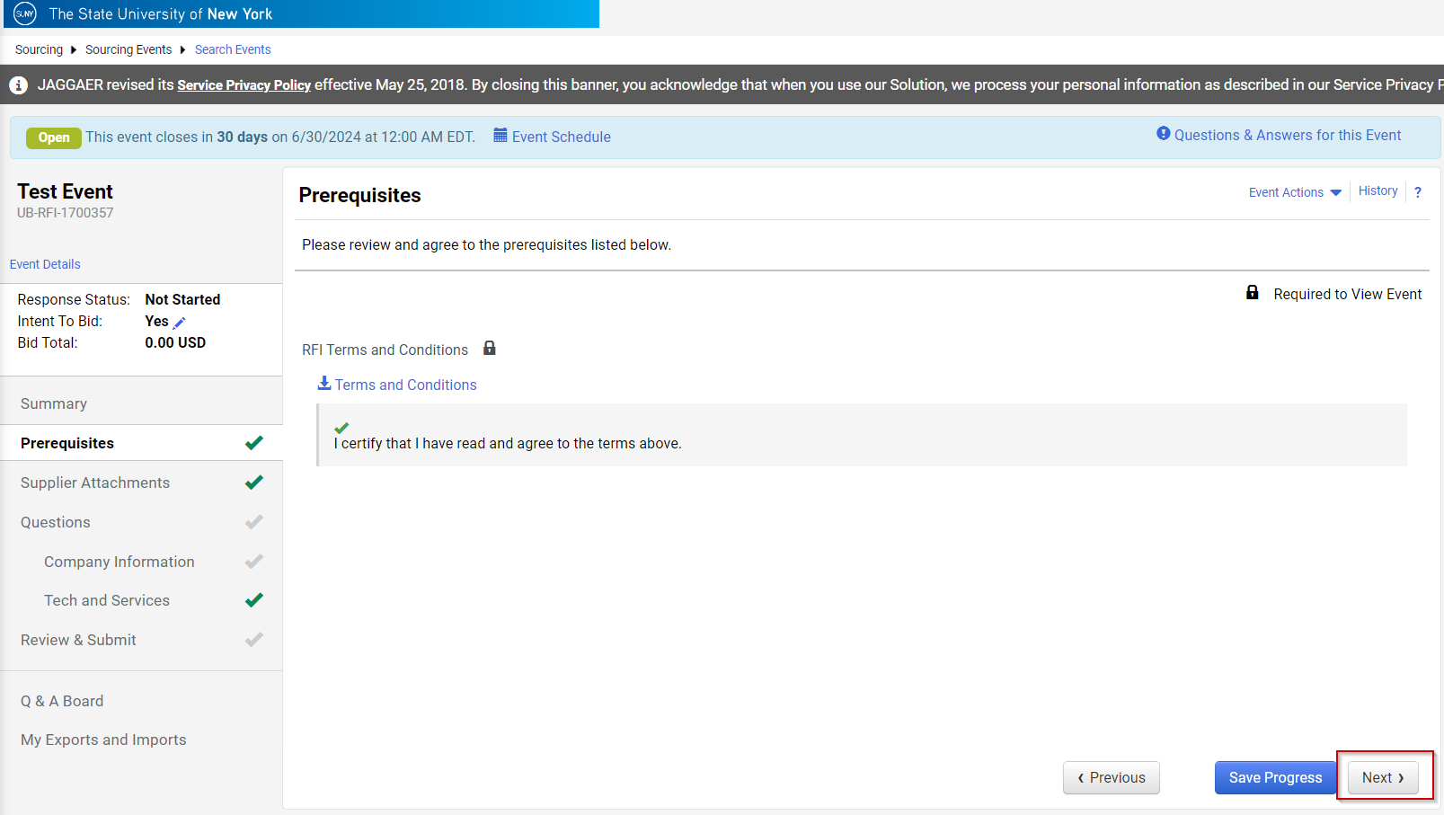

- Click Add New Attachment to upload any additional files that are relevant to this bid response. Click Next.
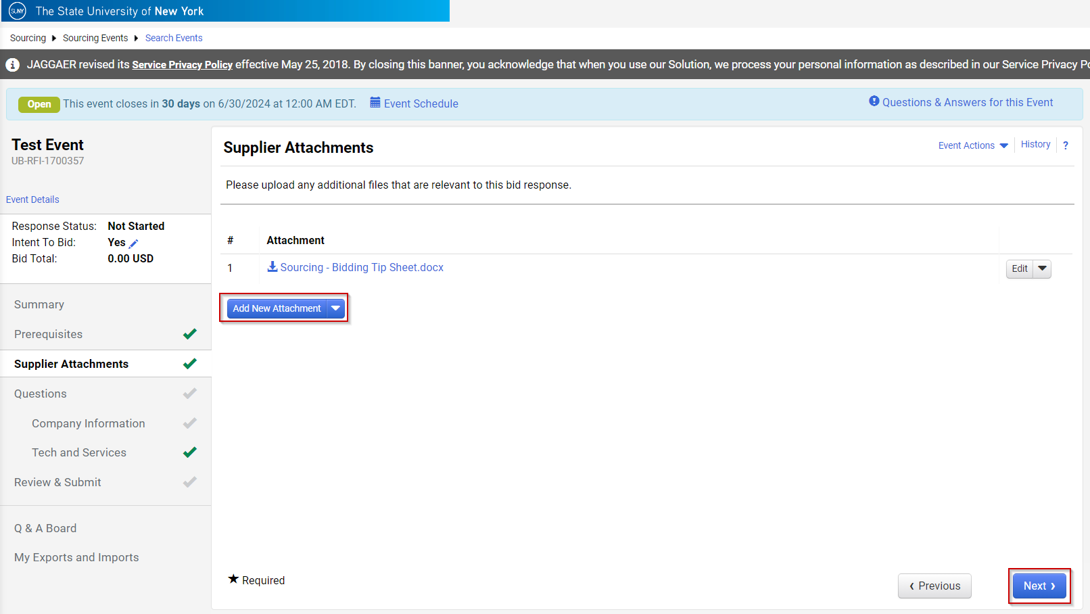

- Click Company Information to add Company Contacts and Company Information. Click Next.
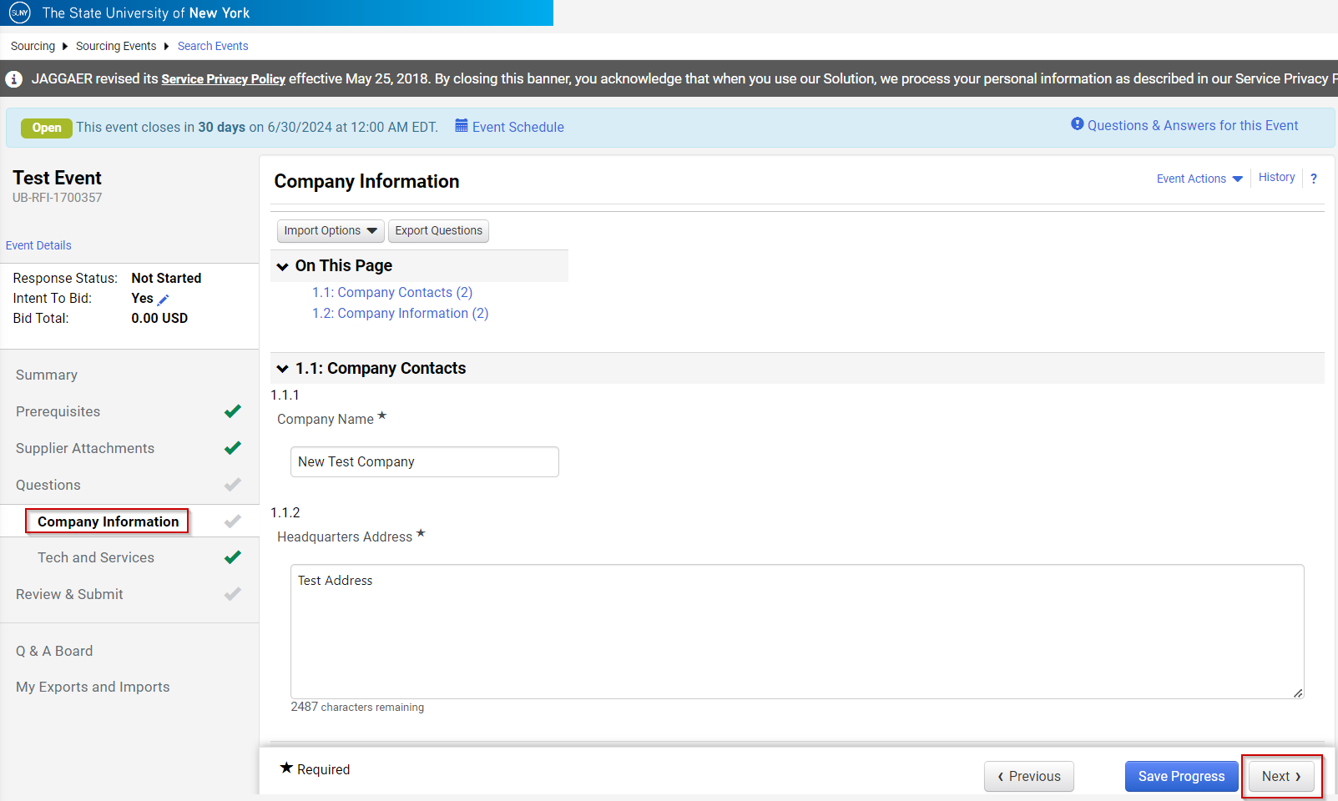

- Click Next on Tech and Services page.
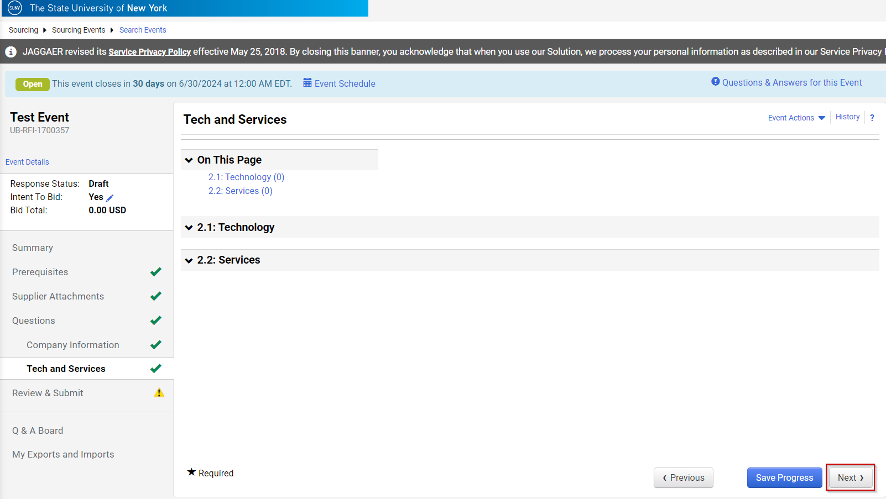
- Click Submit Response once you are done answering questions.
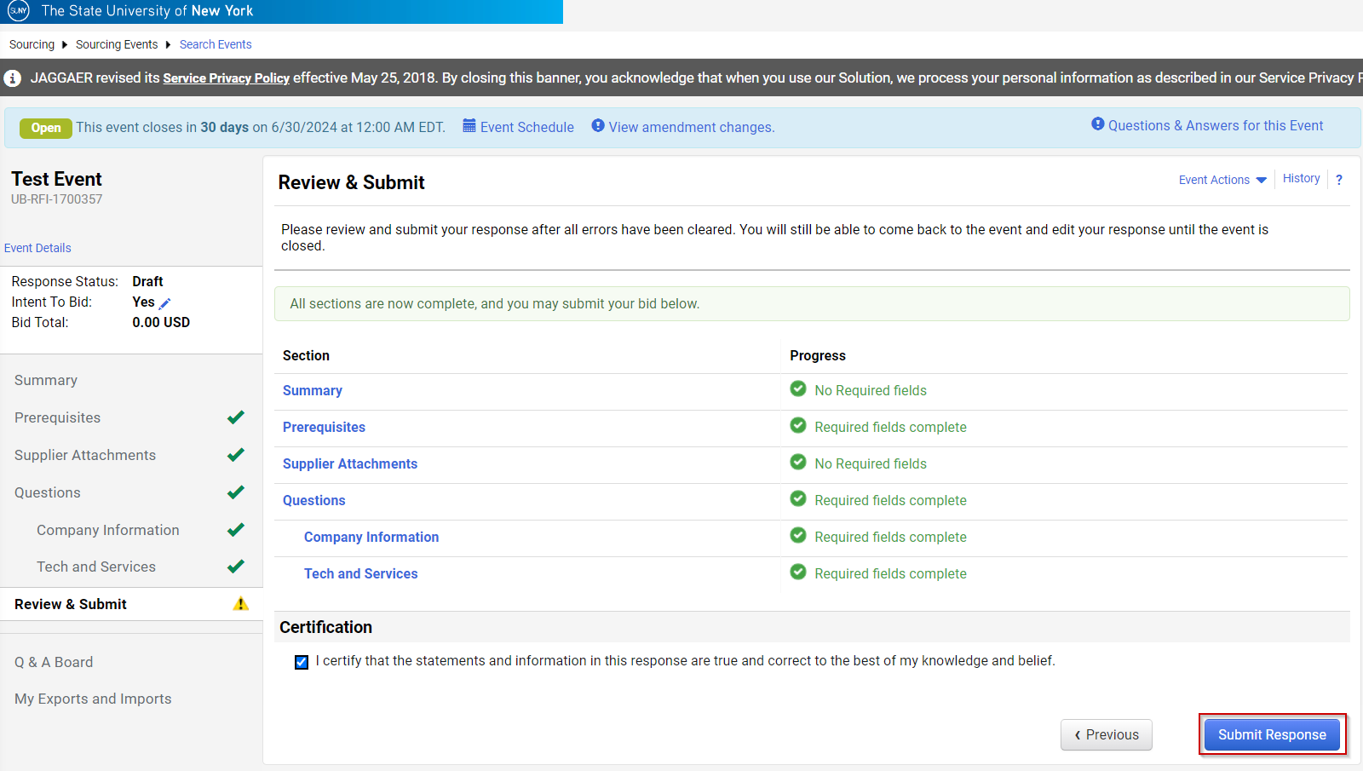

- In case if you want to ask questions related to the event. Click Q & A Board and click Ask a Question. Note: Kindly refer to Q&A timeline before adding your question. Click Summary to view the Question Submission Close Date.
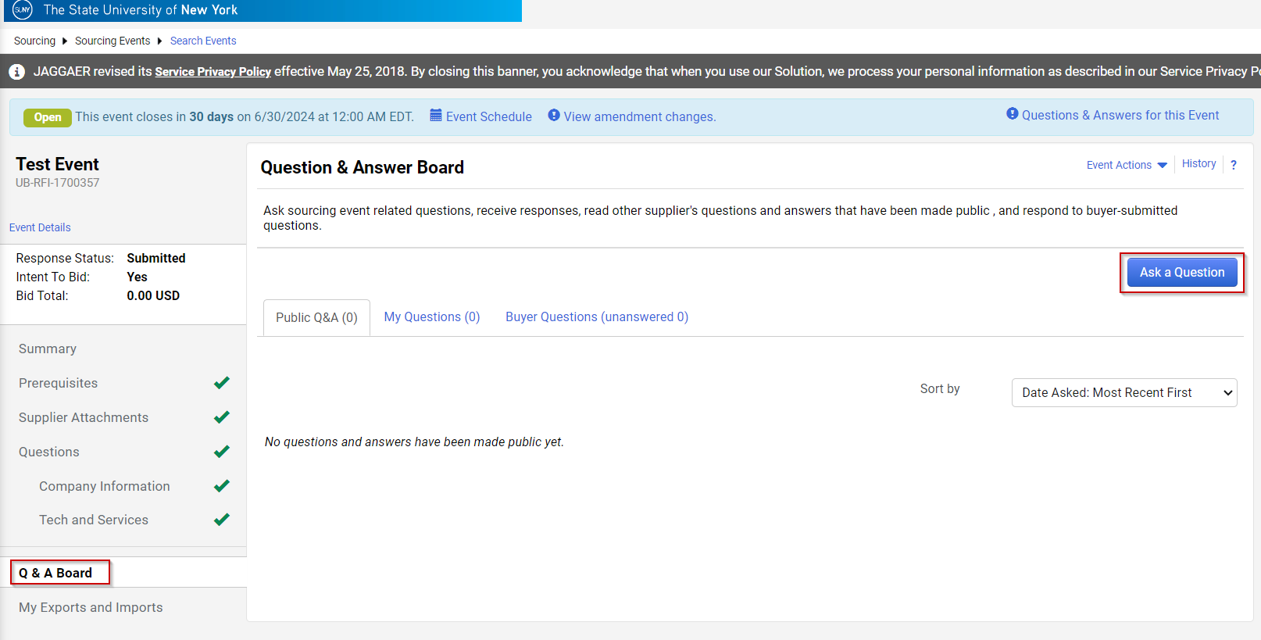

- Add the Subject and your question, add any attachment and click Submit Question.
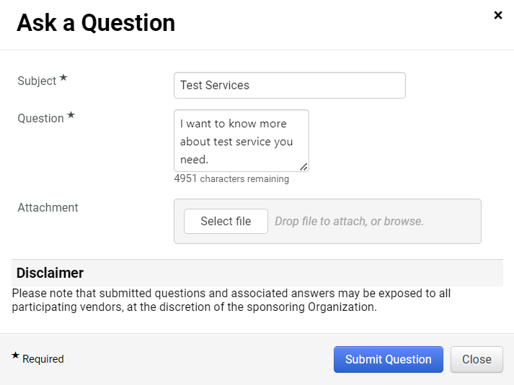
- Once your responses have been submitted, you will have to wait for the Sourcing event to complete. Once the event is awarded the event status will change to Awarded, and you may click on Your Award Summary to view if you have been selected to award any of the items from RFI.
